horizontal line

**Nazneen Marsook**

Batch 75

Optimization of Machine Downtime

**4th September 20XX**

# 

# Business Problem :

Unplanned machine downtime , leading to loss of productivity

# Business Objectives :

Minimize unplanned machine downtime

# Business Constraints :

* MInimize maintenance cost
* Maximize equipment efficiency

# Success Criteria :

## Business Success Criteria -

Reduce the unplanned downtime by at least 10%

## Economic Success Criteria -

Achieve a cost saving of at least $1M

**PROJECT OVERVIEW**

Unplanned downtime in manufacturing refers to unexpected periods during which a system or equipment unexpectedly stops working or becomes non-operational, disrupting the normal workflow and production processes. It is a critical factor that significantly affects the operational efficiency and bottom-line impact of manufacturing facilities. It happens due to unforeseen issues, such as mechanical failures, operator errors, or external factors like power outages.

Machine learning can help optimize maintenance schedules, detect anomalies, and forecast failures by analyzing historical data and real-time machine parameters. This approach can significantly reduce unplanned downtime, improving efficiency and cutting costs.

The factors considered in this dataset are -

Date - the date when the data was recorded.

Machine ID - Unique identifier for each machine.

Assembly Line Number - Identifier for the assembly line the machine belongs to.

Hydraulic Pressure - Represents the pressure in the hydraulic system, measured in bars.

Coolant Pressure - Coolant pressure reading in bars.

Air System Pressure - Air system pressure in bars.

Coolant Temperature - Temperature of the coolant.

Hydraulic Oil Temperature - Temperature of the hydraulic oil given in °C.

Spindle Bearing Temperature - Temperature of the spindle bearings in °C.

Spindle Vibration - Spindle vibration in micrometers.

Tool Vibration - Vibration of the tool in micrometers.

Spindle Speed - Spindle speed in revolutions per minute (RPM).

Voltage - Voltage reading in volts.

Torque - Torque applied in Newton-meters (Nm).

Cutting - Cutting force in kilonewtons (kN).

Downtime - The target variable indicating the cause of machine downtime - whether machine failure or not.

**PROJECT INSIGHTS**

There are 2500 rows/records and 16 columns/fields.

The columns Date, Machine_ID, Assembly_Line_No and Downtime are of object type. Remaining all columns are numerical.

There are 143 null values across the numerical columns.

**Hydraulic Pressure**



MOMENTS OF BUSINESS :

Mean : 101.41

Median : 96.76

Mode : 3 modes : 88.279134, 89.458747, 90.458747

Variance : 917.4417 bar

Standard Deviation : 30.29

Range : 205.327

Skewness : 0.197

Kurtosis : -0.920292

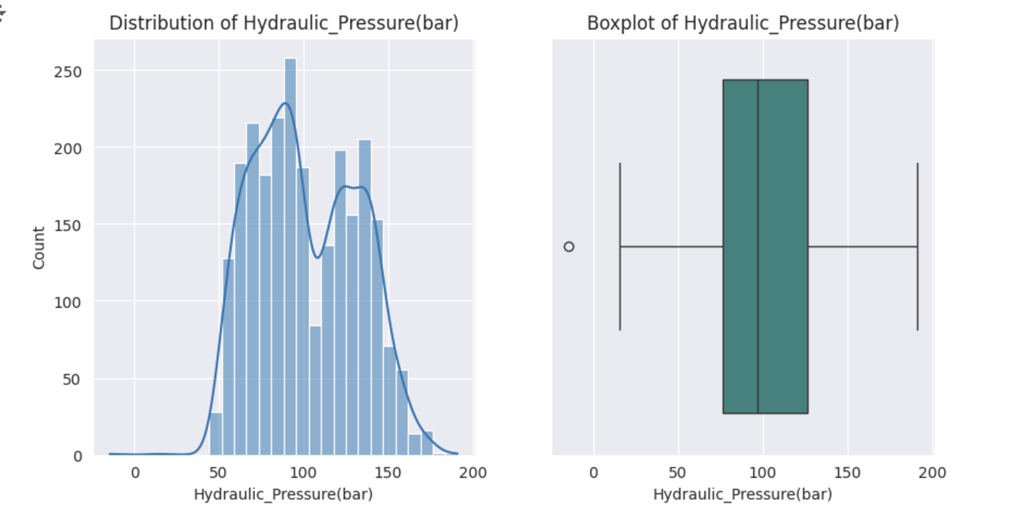

### **Statistical Insights :**

1. The minimum value is -14.33. It can be an error in measurement or wrong entry and can be treated as an outlier as pressure is usually positive. This value is the only outlier according to the box plot above.
2. The mean (101.41) is slightly higher than the median (96.76). It indicates a right-skewed distribution. Considering the skew value = 0.197, we can say it is slightly positive skewed but almost symmetrical. So no transformation is required. We can consider mean value imputation for missing values.
3. The multiple modes (88.28, 89.46, 90.46) point out the small clusters at those points.
4. The negative kurtosis (-0.920292) points to a platykurtic distribution. It is visible in the histogram plot. The data has thinner tails and less extreme values compared to a normal distribution
5. The range (205.327) shows that there is a big difference between the minimum and maximum pressure values. It points out the wide operational limits.
6. The variance (917.4417) and standard deviation (30.29) suggest some spread in the hydraulic pressure values.

### **Business Insights :**

1. The slight right skewness shows that the system operates at higher pressures also. Consider the reasons for the high pressure operations, like, is that for a particular product or for larger quantities, and make relevant requirements to reduce the frequency of such operations. If high pressure operations are unavoidable, frequent maintenance work is suggested.
2. The Range value is very large. Again, check the reasons for high pressure variations. It might cause a lesser lifespan of the machine and causes downtime due to its failure.
3. There are three modes which are lesser than mean values. These might be a particular product / task or phases of operation. It shows that the machine usually operates under an optimum pressure which is very relieving.
4. The safety hazards of high pressure working conditions must be considered.

### The reason for a negative value for pressure should be investigated.

1. Investigate if high pressure values cause a machine failure and downtime.
2. Wear and tear of the machinery must be addressed regularly to minimize maintenance cost and maximize equipment efficiency.

**Coolant Pressure**





MOMENTS OF BUSINESS :

Mean : 4.95

Median : 4.94

Mode : 8 modes : 4.566854, 4.842521, 5.567857, 5.918357, 6.560332, 6.839413, 6.863944, 6.893182

Variance : 0.9947

Standard Deviation : 0.997

Range : 11.025

Skewness : 0.147

Kurtosis : 1.169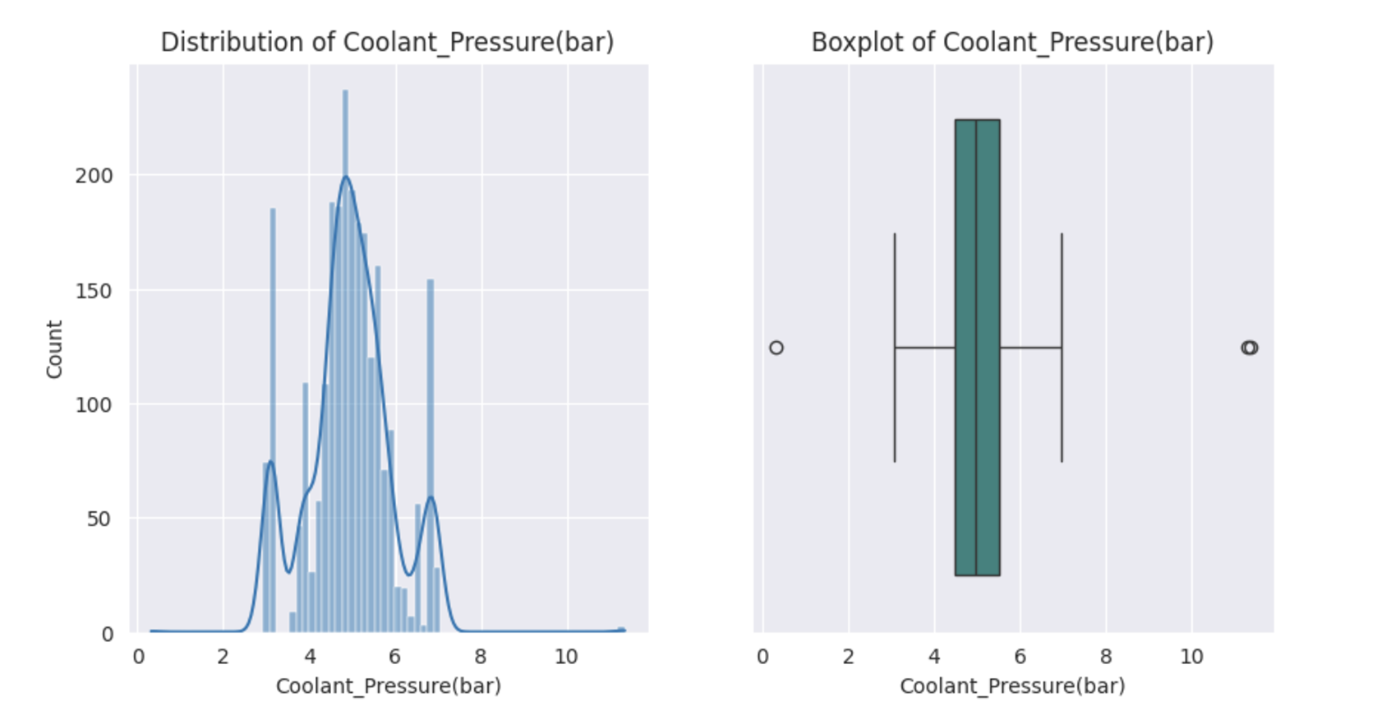

### **Statistical Insights :**

1. The mean (4.95) is almost equal to the median (4.94). So it is a symmetric distribution although a bit positive skewed (0.147). As in the plot, it has a small tail towards extreme values.The outliers do not affect too much.
2. There are eight modes. So that might be any distinct operational cluster for a specific task or operational phase.
3. Since the variance is closer to 1 (0.9947) , both variance and standard deviation (0.997) are closer. So there is only a narrow spread in the values. That points out that the pressure conditions for coolant are consistent throughout the process.
4. But the range (11.025) is very high. It might be due to occasional extreme conditions in operation.
5. The kurtosis (1.169) shows that it is a leptokurtic distribution i.e, more frequent valuesound the mean and fewer extreme values compared to a normal distribution.

### **Business Insights :**

1. The extreme operation conditions are to be investigated since the range is 11.025 . If its impact is high on the system, those situations are to be addressed properly to minimize maintenance cost and increase the lifespan of the machinery.
2. The fact that the spread is very less indicates a stable operational environment which makes it easier for the monitoring and regulating the performance.
3. The extremes are to be analysed to find out if it is an error in the functioning of the machinery. If so, it is to be corrected to maximize the equipment efficiency.
4. Investigate if the high pressure operating conditions and downtime are correlated.

**Air System Pressure**





MOMENTS OF BUSINESS :

Mean : 6.499

Median : 6.505

Mode : 11 modes : 5.628717, 5.928643, 5.955235, 6.011483, 6.167549, 6.430073, 6.668245, 6.753560, 6.836188, 6.875058, 6.940606

Variance : 0.166

Standard Deviation : 0.4073

Range : 2.911

Skewness : -0.0529

Kurtosis : -0.001578

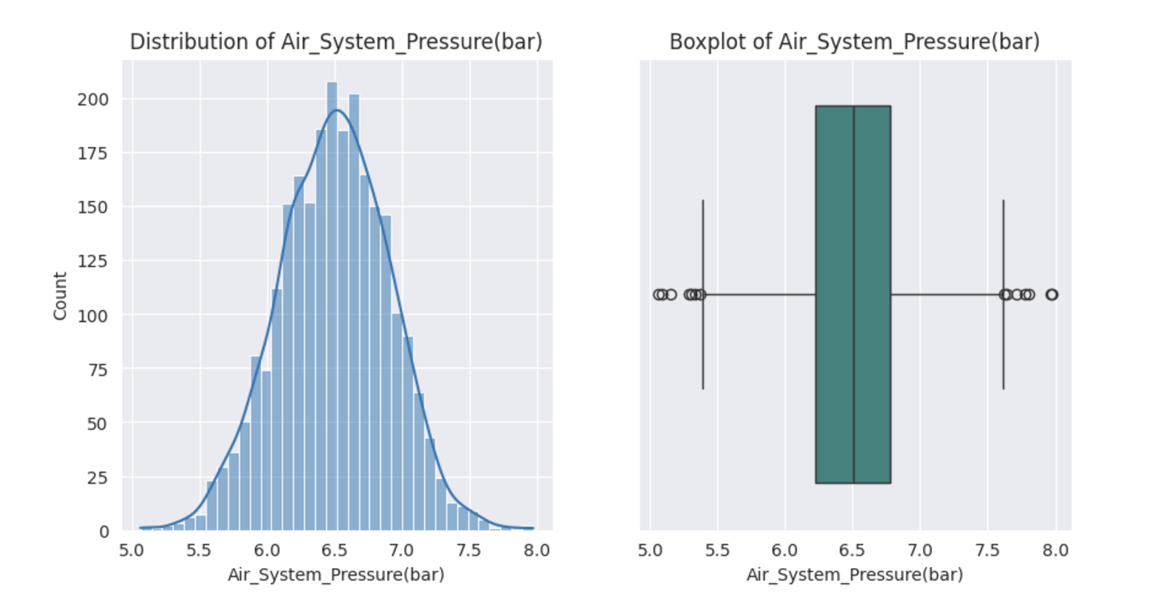

### **Statistical Insights** :

1. The mean (6.499) and median (6.505) are almost equal. So air system pressure values have a symmetric distribution. It is visible in the histogram also.
2. We can see outliers in the box plot. But the value of range is very small when compared to mean and median values. It suggests a stable air system pressure.
3. The number of modes is 11. It means the machine is performing under multiple operating conditions.
4. The variance (0.166) and standard deviation (0.4073) are quite low. So all the values are clustered around the mean.
5. Skewness is very low : -0.0529. It is a little bit negatively skewed. But as in the histogram plot, the effect of outliers can be ruled out.
6. The kurtosis (-0.001578) is very close to 0. So it is a mesokurtic distribution similar to a normal distribution, with no unusual concentration or extremes in the data.

### **Business Insights :**

1. The low standard deviation and small range indicates that the air system pressure is highly consistent. So it has a stable operational environment.
2. The 11 modes denote different phases of operation or tasks. It can be further analyzed for optimization of equipment efficiency.
3. The narrow curve suggests the system operates under strict conditions. The extreme conditions are almost nil. It assures precision in the performance and safety of the machinery.
4. The thorough investigation of outliers is suggested as the machine is operating under strict conditions, in order to rule out anomalies and potential risks.
5. Regularly monitor the system to ensure stable operations are maintained. Address any fluctuations in the current pattern to detect degradation of the machine. Thus maintenance cost can be minimized.
6. Regular maintenance works are required to prevent wear and tear, and to find any issues with the machine body parts.

**Coolant Temperature**





MOMENTS OF BUSINESS :

Mean : 18.559

Median : 21.2

Mode : 1 mode : 26.4

Variance : 0.732

Standard Deviation : 8.554

Range : 94.1

Skewness : 0.108

Kurtosis : 1.565

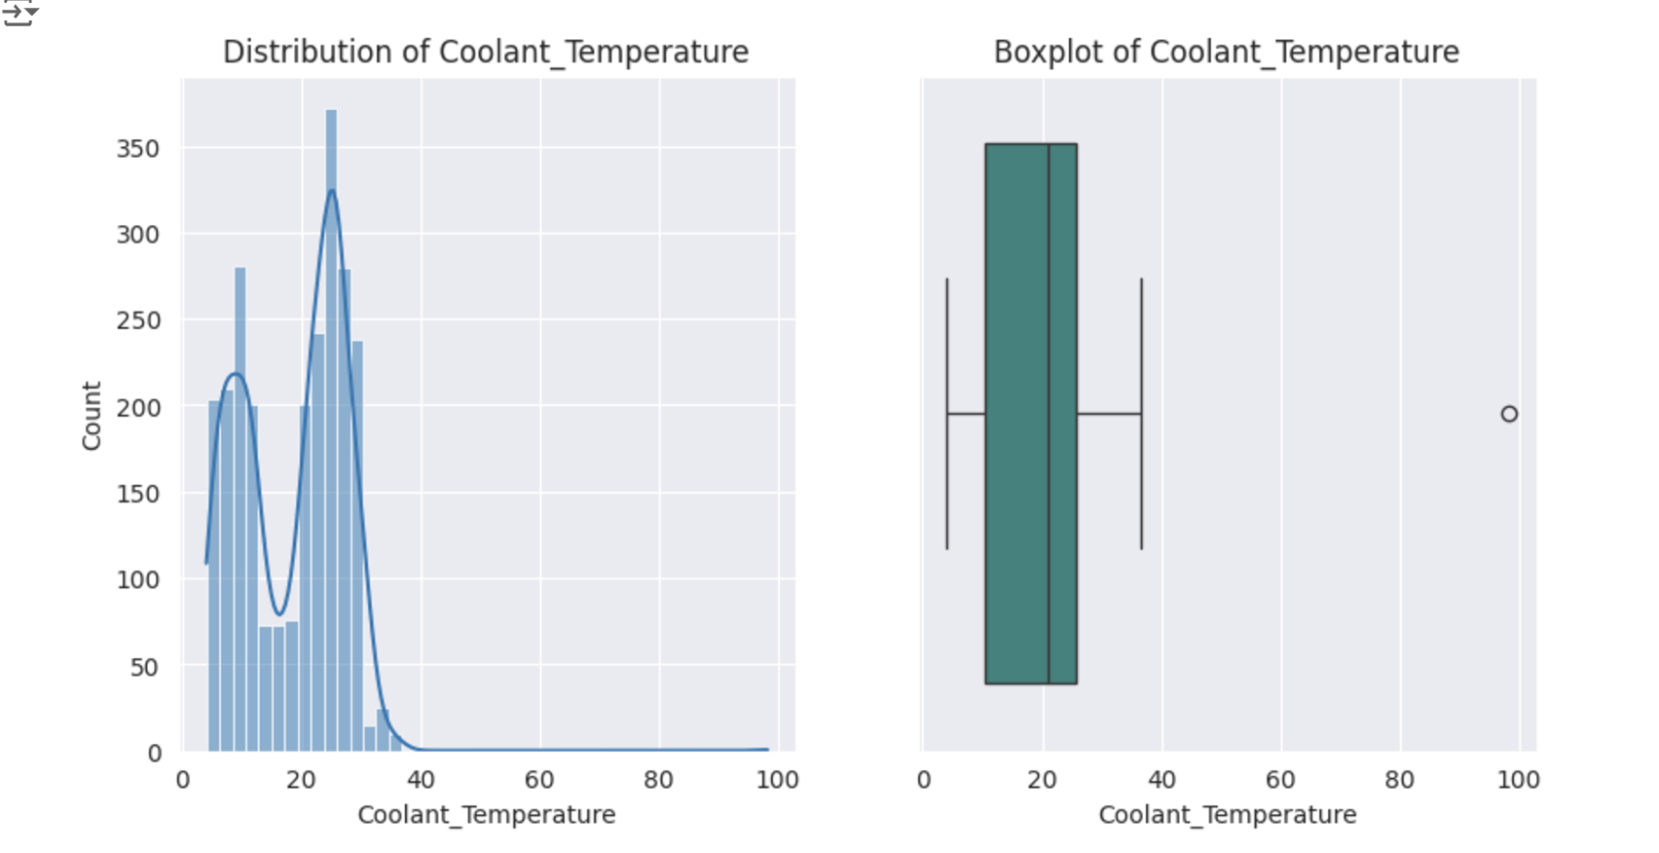

### **Statistical Insights :**

1. The mean (18.559) is lower than the median (21.2). So the column is skewed(0.108).
2. The mode is at 26.4. It represents the normal operational state.
3. The range (94.1) is very large compared to the mean. It points out the possibility of outliers. It says the machine worked under high temperature also, may be due to high workload.
4. The kurtosis (1.565) is greater than 0, indicating a leptokurtic distribution with a higher concentration of values near the mean and potentially more extreme outliers compared to a normal distribution.

### **Business Insights :**

1. The mode at 26.4 suggests that most of the operations occur near this temperature, which might be the standard coolant temperature. Optimize other factors to get maximum efficiency at this temperature. Analyze if this working condition is ideal for the system.
2. The large value of range (94.1) and 75% values under 25.2 indicate that the system works under fluctuating coolant temperature. Ensure that the fluctuation does not deteriorate machine lifespan and performance.
3. The occasional high temperature performance is to be analyzed whether it caused any downtime in the past.
4. The max value 98.2 is to be checked for any anomalies or specific operations. If it is due to overheating and affects the longevity of the components, such operational conditions have to be reviewed.
5. Regularly monitor the system to ensure stable operations are maintained. Address any fluctuations in the current pattern to detect any deterioration of the machine and reduce maintenance cost.

**Hydraulic Oil Temperature**





MOMENTS OF BUSINESS :

Mean : 47.618

Median : 47.7

Mode : 3 modes : 47.5, 48.0, 50.0

Variance : 14.203

Standard Deviation : 3.769

Range : 26.199

Skewness : -0.0023

Kurtosis : 0.038

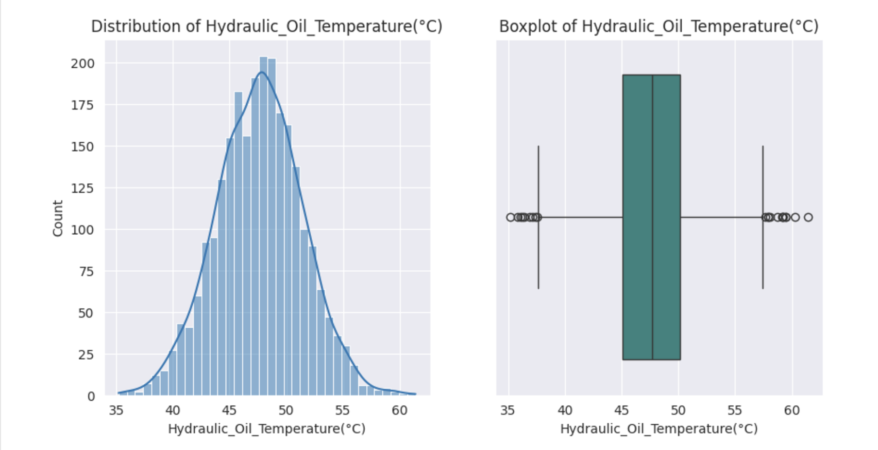

### **Statistical Insights :**

1. The mean (47.618) is very close to the median (47.7). The skewness (-0.0023) is very close to zero. The distribution of hydraulic oil temperature values is symmetric or normal as seen in the plot.
2. There are three modes (47.5, 48.0, 50.0). It may be due to three different operational phases.
3. The standard deviation (3.769) and variance (14.203) is low compared to mean. So the system is working under stable operational conditions.
4. The range (26.199) is small compared to mean, ruling out any anomalies.
5. The kurtosis (0.038) is near zero, indicating a mesokurtic distribution (similar to a normal distribution), where the probability of extreme values is neither high nor low.

### **Business Insights :**

1. The skewness is almost zero. So chances of a very high temperature operation or low temperature operation is nil. It favors the lifespan of components.
2. The small range and variability assures that the machine is working under stable conditions, without overheating. So overheating issues of the components can be ruled out and minimize the maintenance cost.
3. The three modes at 47.5, 48.0, 50.0 indicate the system temperature for various phases. The existing system for heating and cooling has to be maintained properly in order to keep up with the equipment efficiency.
4. Proper monitoring system is recommended as fluctuations in temperature are hazardous for the whole manufacturing unit.

**Spindle Bearing Temperature**





MOMENTS OF BUSINESS :

Mean : 35.064

Median : 35.1

Mode : 1 mode : 34.6

Variance : 14.174

Standard Deviation : 3.765

Range : 26.9

Skewness : -0.0359

Kurtosis : -0.0439

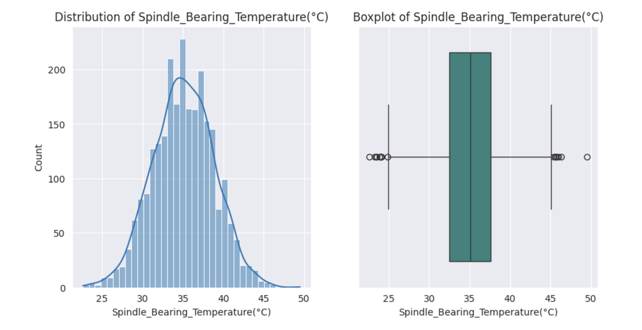

### 

### **Statistical Insights :**

1. The close mean (35.064) and median (35.1) indicates a symmetrical distribution of spindle bearing temperature values, as seen in the plot. The mode (34.6) is also near the mean and median.
2. The standard deviation (3.765) and variance (14.174) indicate low variability, meaning the spindle bearing temperature is relatively consistent.
3. The range (26.9) is moderate when compared to mean. So the temperature varies in a relatively moderate range which is under permissible limits.
4. Since the skewness (-0.0359)and the kurtosis (-0.0439) is almost zero, there is no slant toward high or low temperatures. So the outliers are neither too common nor too rare.

### **Business Insights :**

1. The symmetrical distribution and narrow spread indicate that the temperature is well-regulated, minimizing the chances of overheating and thereby maintenance costs.
2. All the three measures of central tendency clustering around 35°C suggest that the system is operating at a constant and consistent temperature. If you optimize all the settings properly, spindle life can be extended. Thus equipment efficiency can be maximized.
3. The outliers, even though rare, need to be investigated thoroughly, whether the spindle breakdown and downtime is associated with the outlier values.
4. A proper monitoring system is recommended to address unexpected temperature fluctuations, which can impact the spindle's performance and lifespan.
5. Since the range of values are moderate and the outliers are less extreme, a predictive model can be built for monitoring and optimization.

**Spindle Vibration**





MOMENTS OF BUSINESS :

Mean : 1.009

Median : 1.008

Mode : 1 mode : 1.231

Variance : 0.118

Standard Deviation : 0.343

Range : 2.461

Skewness : 0.0015

Kurtosis : -0.0187

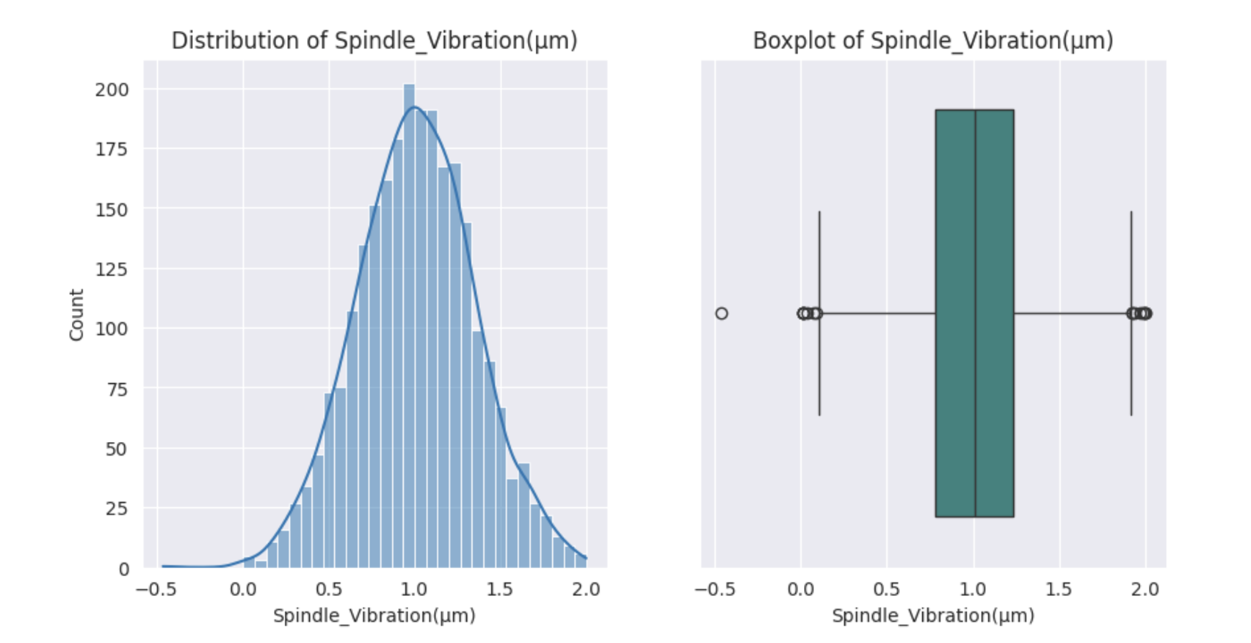

### **Statistical Insights:**

### The mean (1.009) and median (1.008) are almost identical. So it is a symmetrical distribution. The skewness (0.0015) is also nearly zero.

1. The mode (1.231) is greater than the mean and median. So there is a cluster of values around this point.
2. The variance (0.118) and standard deviation (0.343) is low. So the spindle vibration is consistent without deviating much from the mean.
3. The minimum value -0.46 looks like a measurement error or noise. It contributed to a higher range (2.461) also.

### **Business Insights :**

1. The outlier at -0.46 seems to be a measurement error. It is far away from the lower whisker. This record needs to be investigated thoroughly and find out the causes if it is a true value. Evaluate the performance of the whole system for this record.
2. The variance is low to moderate, so the spindle vibration is under regulated atmosphere. Optimize it further to increase efficiency and reduce downtime.
3. A proper monitoring and regulating system is recommended to address any sudden spikes or dips in vibration levels, which can impact the spindle's performance and lifespan.
4. The symmetric distribution indicates minimal anomalies in spindle vibration.
5. Regular checks can help maintain stable operations. It can minimize the maintenance cost.

**Tool Vibration**





MOMENTS OF BUSINESS :

Mean : 25.412

Median : 25.455

Mode : 2 modes : 26.736, 30.585

Variance : 41.437

Standard Deviation : 6.437

Range : 43.565

Skewness : -0.061

Kurtosis : 0.0065

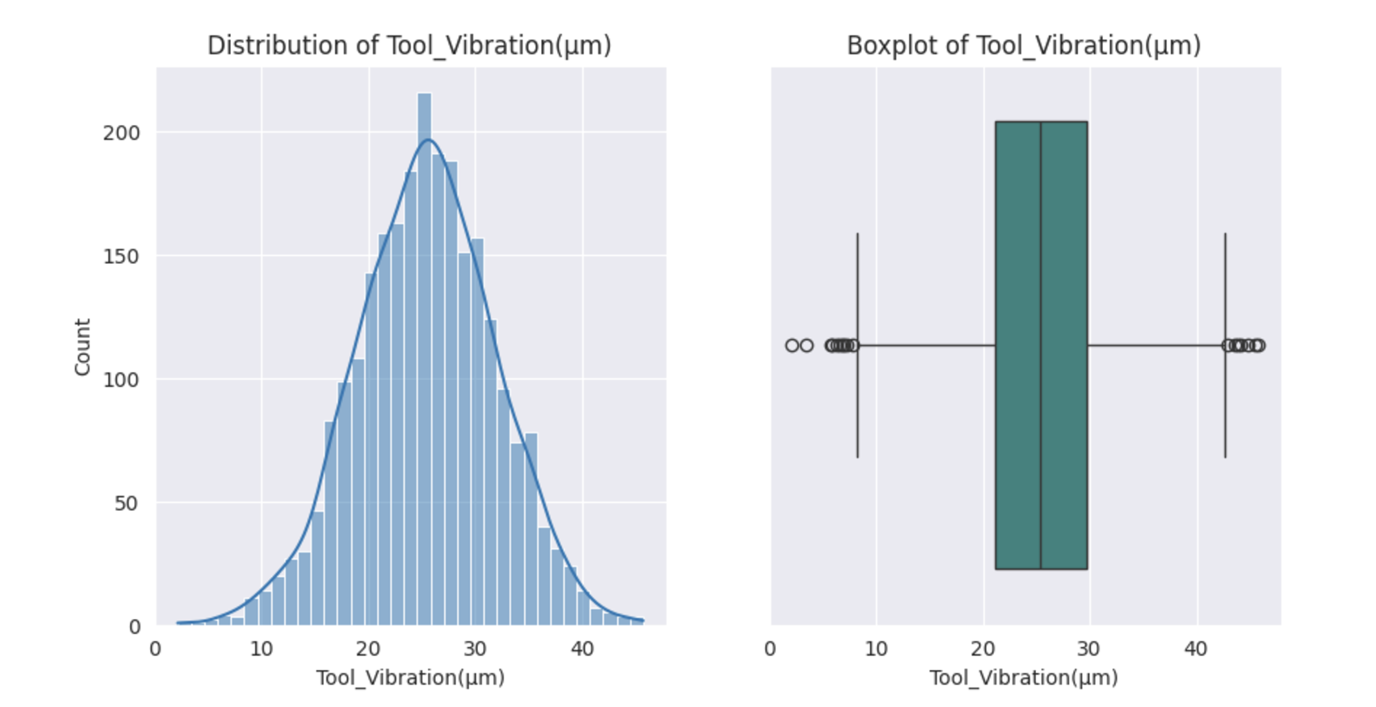

### **Statistical Insights :**

1. The mean (25.412) and median (25.455) are almost equal, and the skewness (-0.061) is close to zero. This indicates a symmetrical distribution of the values as seen in the histogram plot.
2. The modes (26.736, 30.585) are apart from mean and median. It indicates the frequent vibration at these points.
3. The minimum value is at 2.2 and maximum is at 45.7. The higher range shows fluctuations in vibrations.
4. The standard deviation (6.437) and variance (41.437) show a moderate spread, indicating some variability in tool vibration values across observations.

### **Business Insights :**

1. The wide range and minimum value suggest an investigation into the same. It can cause wear and tear in the machinery. It should be rectified in order to reduce the maintenance cost.
2. The box plot shows more outliers in tool vibration values than other columns. Such records should be considered for an evaluation.
3. The high fluctuations in tool vibration values need to be addressed. If it is not optimised correctly, it causes poor performance and shorter longevity.
4. The mode values must be checked to find out if the frequent vibrations at those points are genuine.
5. Optimal vibrations are to be set to avoid unnecessary fluctuations and deterioration of the tool, and finally to maximize equipment efficiency.

**Spindle Speed**





MOMENTS OF BUSINESS :

Mean : 20274.792

Median : 20137.5

Mode : 1 mode : 17726

Variance : 14842990

Standard Deviation : 3852.66

Range : 27957

Skewness : -0.1725

Kurtosis : 1.3448

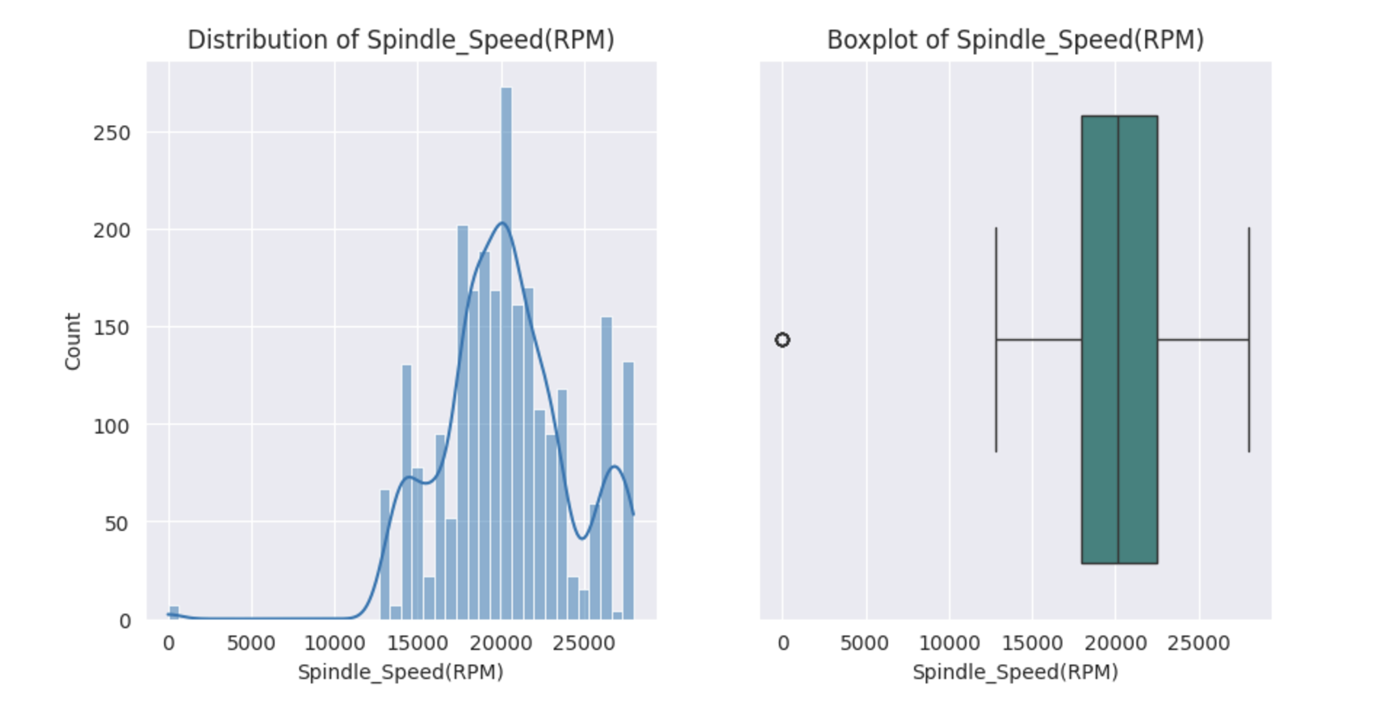

### **Statistical Insights :**

### The mean (20,274.79) and median (20,137.5) are close.So the curve will be almost symmetrical.

1. The mode value (17,726) says that most of the time the spindle speed is consistent at that value.
2. The moderate values of standard deviation (3,852.66) and variance (14,842,990) point out fluctuations in spindle speed throughout the operations.
3. The minimum value ‘0’ can be considered as an outlier.
4. The range (27,957) is very wide. It might be due to different phases of operation.
5. The skewness (-0.1725) says the distribution is skewed to the left.

### **Business Insights :**

1. Since ‘0’ is the minimum value, an investigation is to be done why the spindle is not functioning at that time. Chances are there that it might be an operating condition for a specific phase.
2. The wide range is to be investigated to determine whether it indicates multiple operating conditions or is a result of faulty machinery.
3. The values other than zero lie in between 17500 and 28000. So most of the operations are done in this range. The speed must be regularised for each operation to get maximum output and machinery efficiency.
4. A strong monitoring set up has to be made since the variations and the spread is high. Proper analysis has to be done to find out the optimal conditions for each phase to minimize the maintenance cost and lifespan.

**Voltage**





MOMENTS OF BUSINESS :

Mean : 348.997

Median : 349

Mode : 1 mode : 337

Variance : 2058.984

Standard Deviation : 45.376

Range : 277

Skewness : -0.0287

Kurtosis : -0.0903

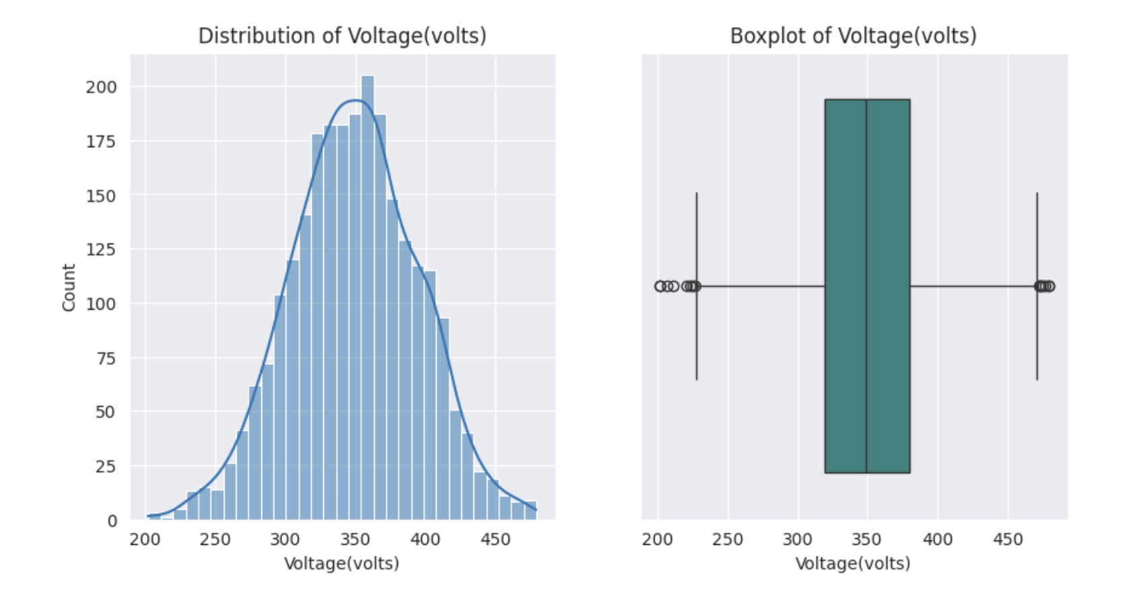

### **Statistical Insights :**

1. The mean (348.997) and median (349) are so close to each other. So it is almost a symmetrical distribution as plotted in the histogram.
2. The skewness (-0.0287) is a very small negative value, and mode (337) is less than mean and median, the distribution is slightly skewed at left.
3. The standard deviation (45.376) and variance (2,058.984) are low compared to mean. It says lesser fluctuations in voltage.
4. The range (277) is wide. It may be due to different operational phases.

### **Business Insights :**

1. The wider range suggests the fluctuations in the voltage, which might be hazardous to the whole manufacturing unit. So proper monitoring is advised to avoid the damage to machinery and thus downtime.
2. The outliers are not at extreme which is very hopeful about the operations. Frequent checks can be performed to foresee the possible damage to the machine. Thus we can reduce the maintenance cost.
3. 75% of the values are under 380V. The remaining 25% are from 380 - 479 V. If it is necessary for a particular phase, precautions have to be done to protect the unit from burn out.
4. If the lower voltage records are due to the inconsistency of power supply, necessary stabilizing techniques have to be performed inorder to ensure the maximum equipment efficiency and lifespan of the components in the whole unit.

**Torque**





MOMENTS OF BUSINESS :

Mean : 25.235

Median : 24.648

Mode : 1 mode : 35.580334

Variance : 37.682

Standard Deviation : 6.139

Range : 55.5524

Skewness : 0.0306

Kurtosis : -0.4656

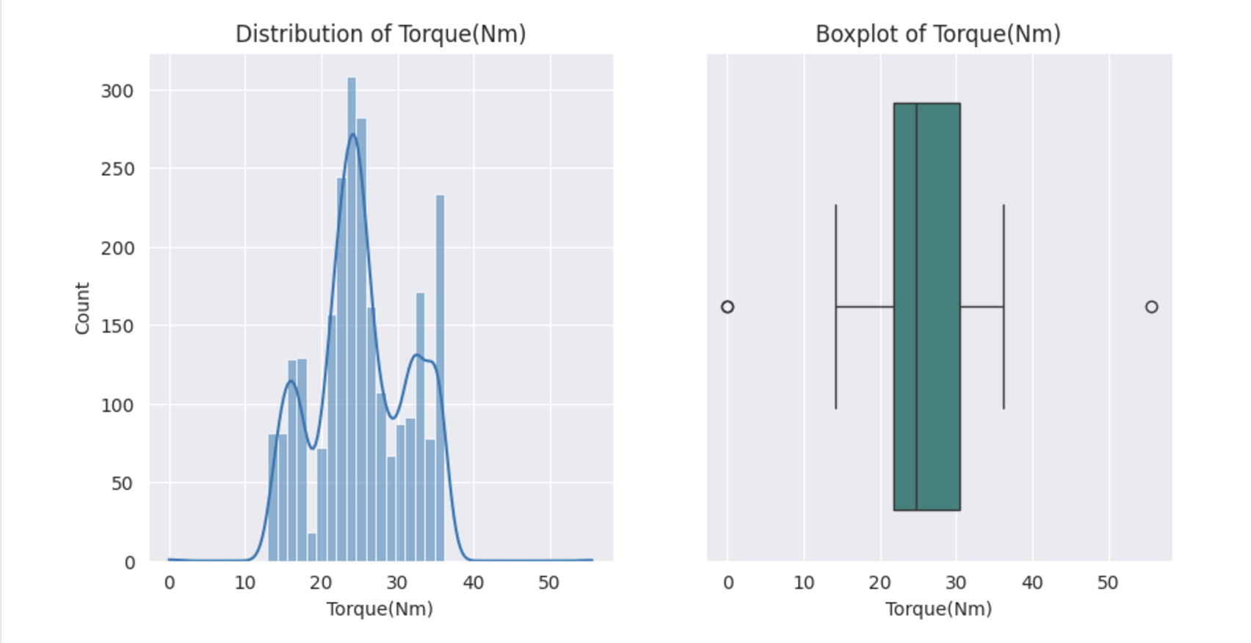

### 

### **Statistical Insights :**

### The mean (25.235) is slightly higher than the median (24.648), and the mode (35.580334) is much higher than the both.

1. The higher value of mode and skewness (0.0306) suggest that the distribution is a bit right skewed.
2. The moderate standard deviation (6.139) and variance (37.682) indicate variations in the twisting force to cause rotations.
3. The minimum value ‘0’ might be an indication that the torque is not required for certain operations.
4. The range (55.5524) is very high, showing that different twisting forces are required for different operations.

### **Business Insights :**

1. From the box plot, it is obvious that minimum and maximum values are outliers. Such values might be errors or torque conditions for different operational phases.
2. The range is very wide and the standard deviation is significant. It may be because the twisting force for different operations of the unit ranges from 0 to 55.55 N.
3. The mode value is much greater than mean and median. So most of the operations require higher rotation of the tools.
4. High torque operations are more for the unit.
5. The multiple clusters observed in the histogram may reflect the most common torque levels required by the machinery during different operational phases.
6. Regular wear and tear checks are required for minimizing maintenance cost and maximizing the equipment efficiency.

**Cutting** 



MOMENTS OF BUSINESS :

Mean : 2.783

Median : 2.78

Mode : 2 modes : 3.55, 3.67

Variance : 0.3803

Standard Deviation : 0.617

Range : 2.13

Skewness : 0.1139

Kurtosis : -1.0872

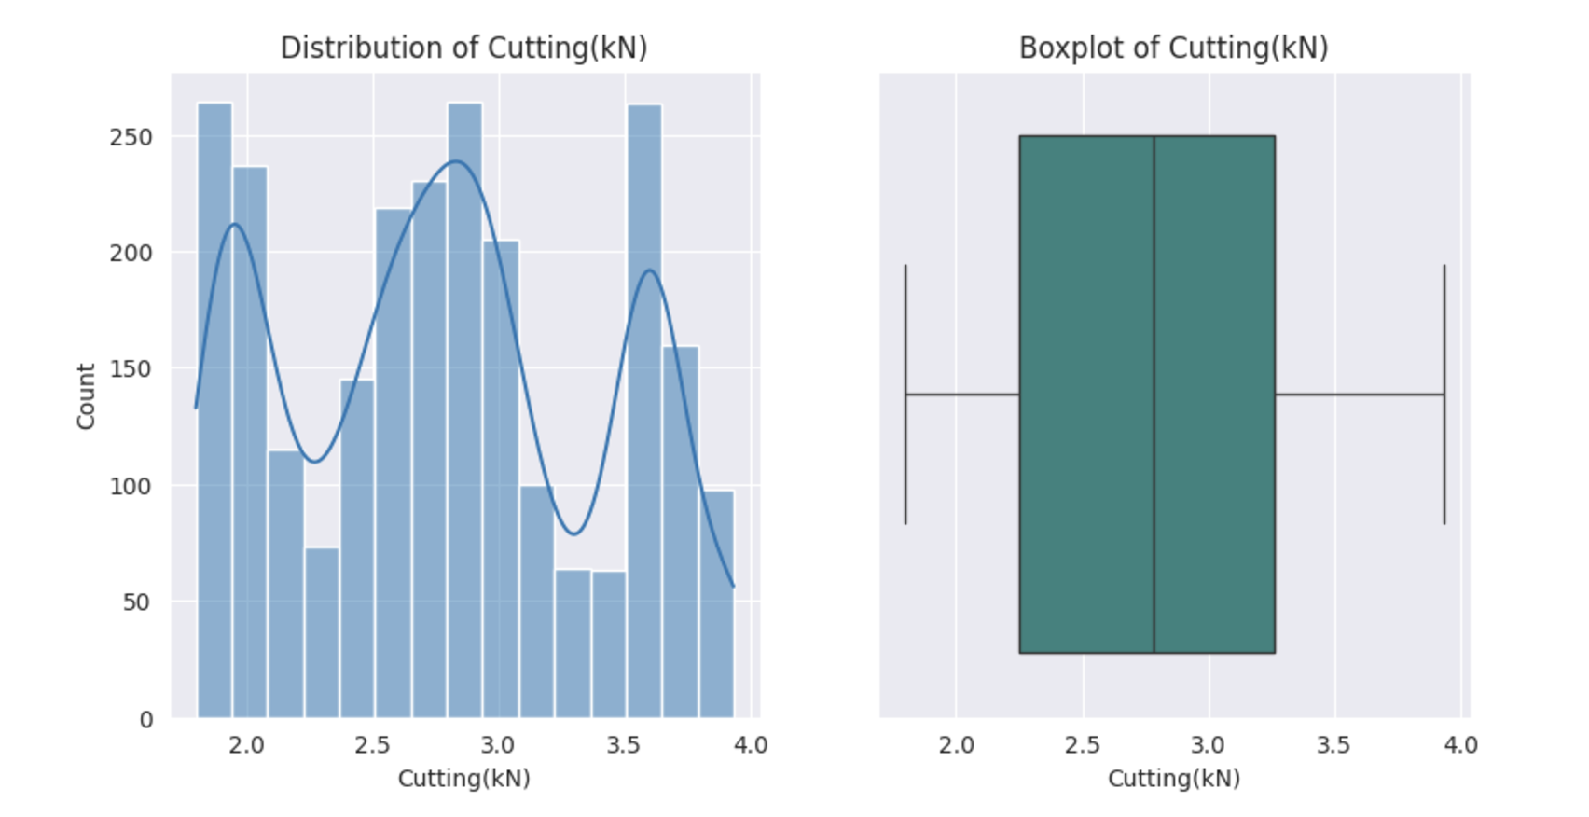

### 

### **Statistical Insights :**

1. The mean (2.783) and median (2.78) are the same.
2. The two modes (3.55, 3.67) are the most frequently occurring cutting forces.
3. The standard deviation (0.617) and variance (0.3803) values are small. So the cutting forces are consistent.
4. Higher range (2.13) throws light on different operations requiring different levels of cutting forces.
5. The skewness (0.1139) is slightly greater than zero. So the distribution is a bit positively skewed.

### 

### **Business Insights :**

1. Two different modes are possibly due to different materials.
2. Outliers are not present in the box plot. So the machine is calibrated correctly for the required operational forces.
3. Regular monitoring of the cutting tools and machines can help in maintaining low variance, minimizing maintenance costs and increasing the operational efficiency.
4. The smaller skewness and moderate standard deviation indicate the optimal functioning of the cutting tool or machine. This can ensure a reduction in downtime due to machine failure.

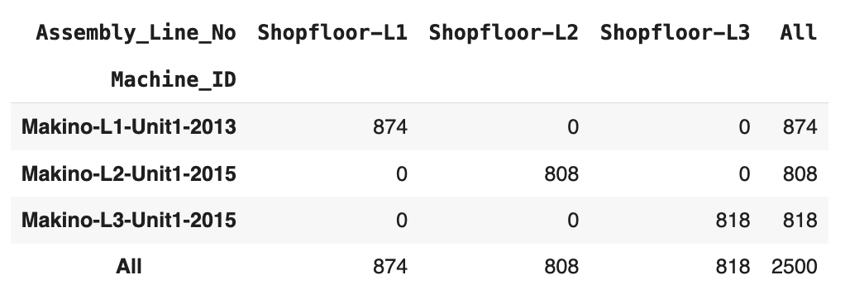

From the above table it is clear that each machine is assembled on a single floor. The Makino-L1-Unit1-2013 is the most used model.

Here both columns convey the same information. It can be assumed that 'L1' in Makino-L1-Unit1-2013 denotes Shopfloor-L1. Similar for the other models too. Hence, the column 'Assembly_Line_No' can be dropped without any loss of information.

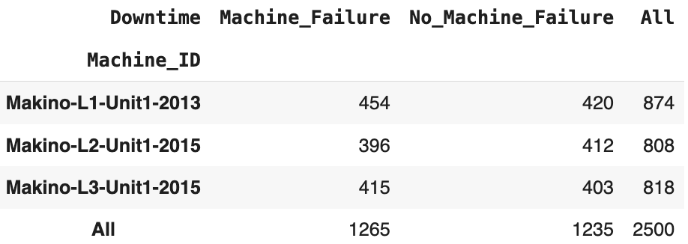

Out of 874 records of downtime in Floor L1, 454 instances of downtime of Makino-L1-Unit1-2013 are due to machine failure. The other 420 instances are due to external factors.

Out of 808 records of downtime in Floor L2, 396 instances of downtime of Makino-L2-Unit1-2015 are due to machine failure. The other 412 instances are due to external factors.

Out of 818 records of downtime in Floor L3, 415 instances of downtime of Makino-L3-Unit1-2015 are due to machine failure. The other 403 instances are due to external factors.

Of all the 2500 occurences of downtime, 1265 events are due to machine failure and 1235 are due to external factors.

**PAIRPLOTS**

1. **Cutting Forces, Torque and Spindle speed Vs Downtime**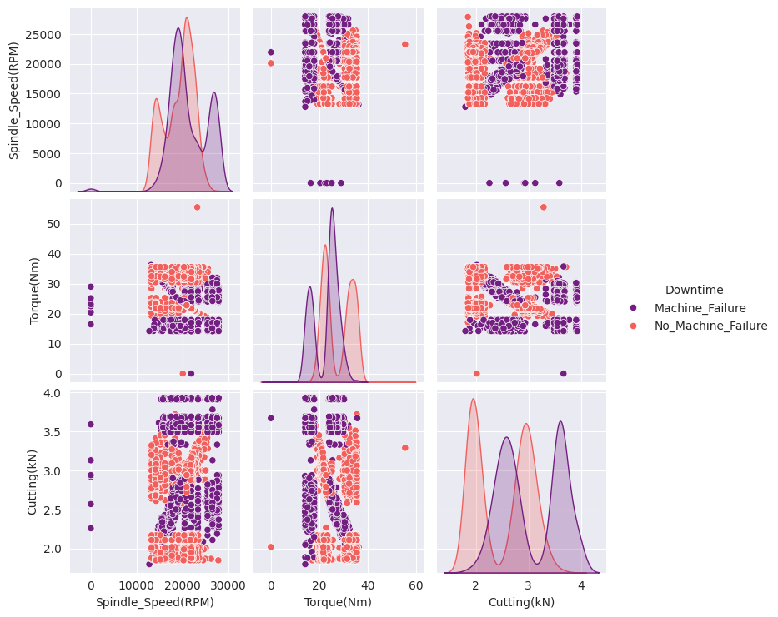
2. Machine_failure is prominent when the spindle speed is higher and the torque values are moderate. Higher torque values with higher spindle speed ensures that there is no_machine_failure.
3. If the spindle speed is zero, machine_failure occurs under all torque and cutting force conditions.
4. For moderate to high spindle speed ranges, if the cutting force is less, downtime will be due to external factors. But for higher values of cutting forces, machine_failure occurs.
5. The chances of breakdown of the machine during lower torque and all values of cutting forces are high.

**2**. **Voltage and forces Vs Downtime**

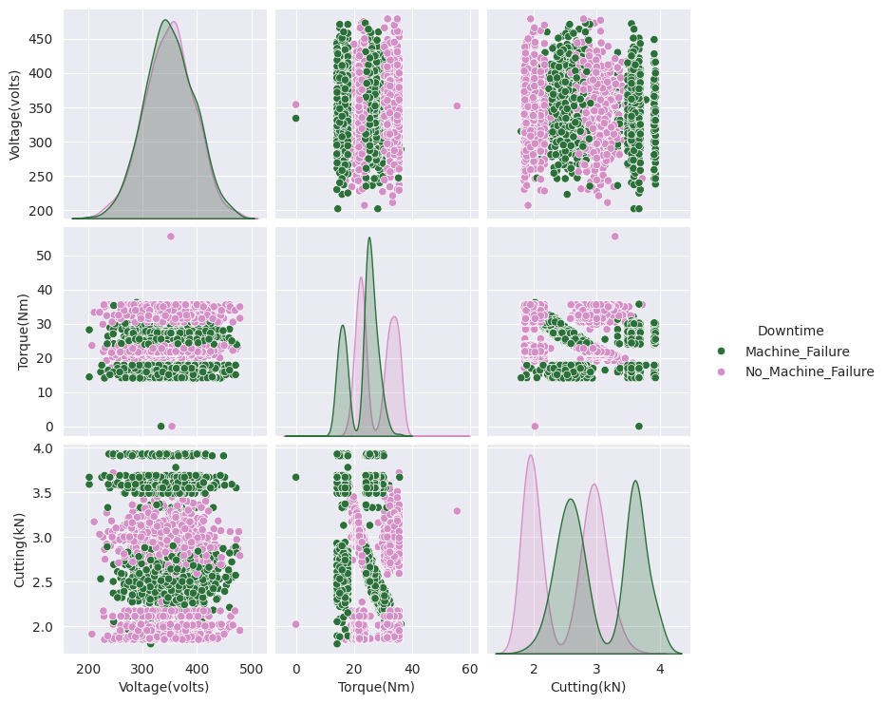

1. The distribution of voltage shows considerable overlap between mahine_failure and no-mahine_failure cases.
2. Lower torque values and varying voltage values cause machine_failure. Chances of machine_failure is decreased for higher torque values.
3. For high cutting forces, machine_failure occurs for whatever the voltage is. But when the cutting force is lower for any voltage, downtime is due to other causes.
4. Lower torque for any range of cutting force results in machine_failure downtime. If the torque is higher in such cases, the possibility of downtime due to external factors is more.

**3. Vibrations and Speed Vs Downtime :**

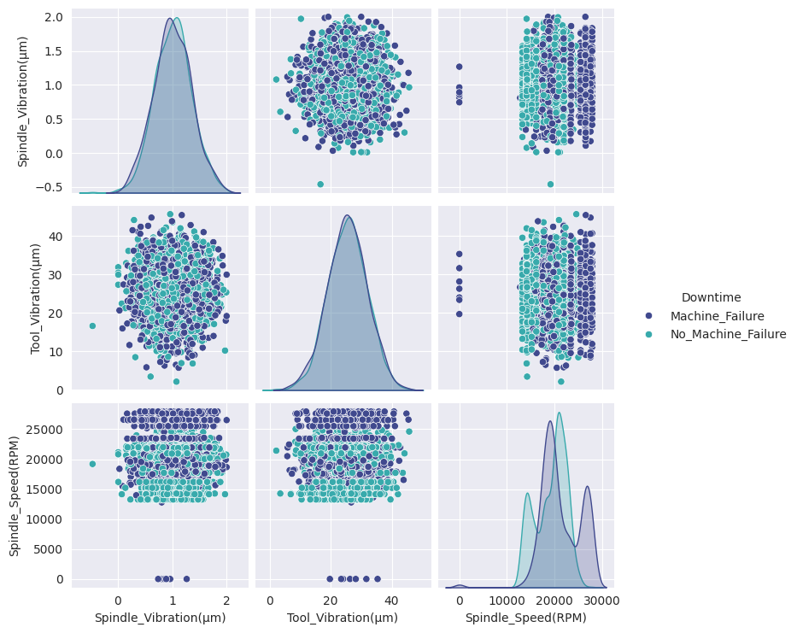

1. The distributions of both the vibrations overlap for no_machine_failure and machine_failure classes.
2. For spindle speed, greater speed causes machine_failure downtime.
3. When spindle speed is zero, machine_failure downtime occurs in every instance.
4. Higher spindle speed also favours machine_failure downtime. The downtime during lower spindle speed might be due to other external factors.

**4. Temperatures Vs Downtime :**

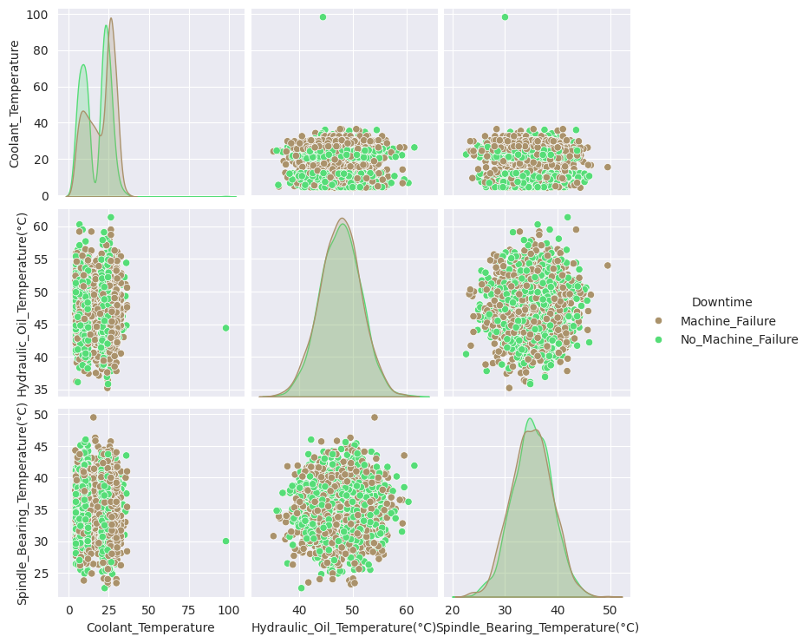

1. The hydraulic oil temperature and spindle bearing temperature has overlapping symmetrical distributions for both cases of downtime.
2. Higher coolant temperature results in downtime due to machine failure.

**5. Pressures Vs Downtime :**

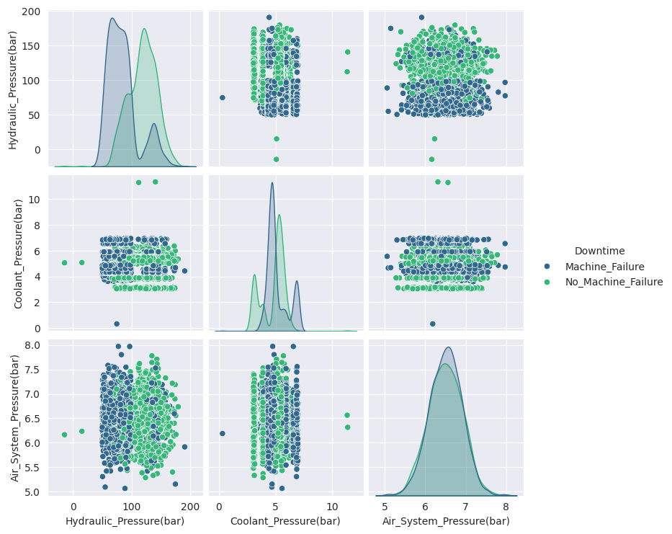

1. Air system pressure has an overlapping symmetric curve for both downtime causes.
2. Lower the hydraulic pressure for varying air system pressure, higher the chances of machine_failure downtime.
3. Higher the hydraulic pressure for varying air system pressure,, the downtime is caused mostly by no_machine_failure causes.
4. Higher coolant pressures also can cause machine_failure downtime.

**CORRELATION MATRIX :**

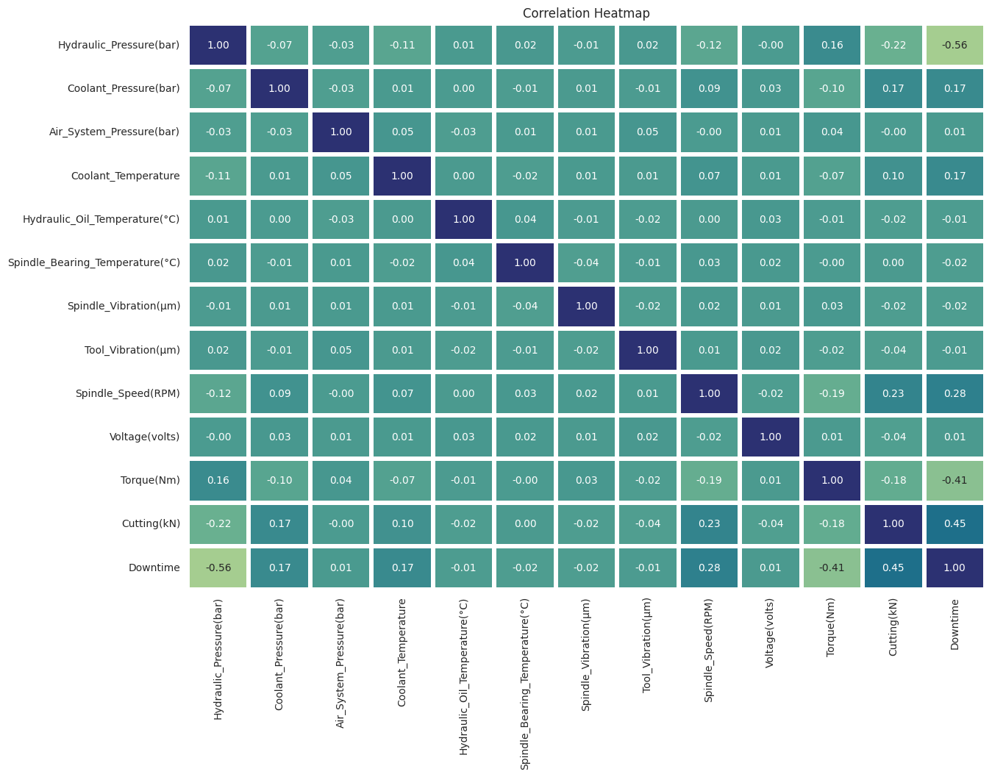

1. Hydraulic Pressure has a strong negative correlation of -0.56 with Downtime. So higher the hydraulic pressure , lower the likelihood of downtime due to machine failure.
2. Cutting force has a moderate positive correlation of 0.45 with Downtime. So higher the Cutting force , higher the likelihood of downtime due to machine failure.
3. Torque has a moderate negative correlation of -0.41 with Downtime. So higher the Torque , lower the likelihood of downtime due to machine failure.
4. Spindle speed has a moderate positive correlation of 0.28 with Downtime. So higher the spindle speed , chances are there for the downtime due to machine failure.
5. Coolant pressure and temperature have weak positive correlation of 0.17 with Downtime. So higher the Coolant pressure and temperature ,chances of downtime due to machine failure is there.
6. The other factors are less correlated to machine failure downtime.
7. Mild correlations are observed between some columns.